Software Requirements Specification
for
Trivia Maze
Version 1.0 approved
Prepared by Multi-threaded Maniacs
Dudes Inc.
October 30, 2019
Table of Contents
Table of Contents ii
Revision History ii
1. Introduction 1
1.1 Purpose 1
1.2 Document Conventions 1
1.3 Intended Audience and Reading Suggestions 1
1.4 Project Scope 1
1.5 References 1
2. Overall Description 2
2.1 Product Perspective 2
2.2 Product Features 2
2.3 User Classes and Characteristics 2
2.4 Operating Environment 2
2.5 Design and Implementation Constraints 2
2.6 User Documentation 2
2.7 Assumptions and Dependencies 3
3. System Features 3
3.1 System Feature 1 3
3.2 System Feature 2 (and so on) 4
4. External Interface Requirements 4
4.1 User Interfaces 4
4.2 Hardware Interfaces 4
4.3 Software Interfaces 4
4.4 Communications Interfaces 4
5. Other Nonfunctional Requirements 5
5.1 Performance Requirements 5
5.2 Safety Requirements 5
5.3 Security Requirements 5
5.4 Software Quality Attributes 5
6. Other Requirements 5
Appendix A: Glossary 5
Appendix B: Analysis Models 6
Appendix C: Issues List 6

Revision History
Name | Date | Reason For Changes | Version

Introduction

Purpose
The purpose of this document is to define the trivia game software. It will define the trivia game software purpose and features, and what the intended use of the software is.

Document Conventions
In this document we are leaving the description within each section for reference purposes.

<Describe any standards or typographical conventions that were followed when writing this SRS, such as fonts or highlighting that have special significance. For example, state whether priorities for higher-level requirements are assumed to be inherited by detailed requirements, or whether every requirement statement is to have its own priority.>

Intended Audience and Reading Suggestions
This document is intended to be used as a reference by developers. Developers are encouraged to update this document when needed.

Project Scope
Trivia Maze is being developed as a fun game that someone can use to answer trivia questions. This can be used for educational purposes if that is the desire or this software can be used for fun.

The user of the software will have the ability to use an admin tool to add questions to the trivia maze for whatever purpose. As well the user will have a cheat mode that they can use to test the maze questions and functionality of the software.

The questions will be stored in a database format. This document will be updated in the near future with exactly what to expect. <ADD STUFF HERE>

References
Java FX Tutorial:

https://www.youtube.com/playlist?list=PLS1QulWo1RIaUGP446_pWLgTZPiFizEMq

This is what we used to learn the basics of Java FX, videos 2 – 3.

Sqlite Tutorial:

https://www.youtube.com/watch?v=JuYb-VZaD1g

This video we used to learn how to set up the database connection and to learn basic interaction.

DB Browser for SQLite:

https://sqlitebrowser.org/

Application download to view and manipulate databases with ease.

Overall Description

Product Perspective
If someone is looking to play a fun game or want a way to educate, they will have the ability to use this trivia maze software.
This software is being developed due to a final project in our CSCD 350 class, Software Development Principle.
This software is not connected to any other outside utilities.

Product Features
Thie Trivia Maze’s main features are the ability to play the game with premade questions. Questions can be in many different formats. These formats are multiple choice, true false, sound, and video.
The maze will be a five by five maze. The user will start in a random location within the maze and choose to go through doors. Each door the user chooses will prompt them with a question. If the user answers the question correctly then they pass through the door otherwise the door becomes locked and they can no longer try to pass through that door again. Once the user is at the exit the game ends and they can play again.
Other features this software include are a couple modes. These modes are cheat mode and admin tool. The admin tool allows the user to add their own questions to the game. Cheat mode allows the user to pass through doors.

User Classes and Characteristics
Basic User Class - anyone
This user class will have a desktop or laptop.

Operating Environment
Development of the software will be on Windows 10 and will be tested on Windows 10. Core programming language will be Java and specifically will be version 1.8.

Design and Implementation Constraints
We have no limitations.

User Documentation
Within the application the user can navigate through info > help which will guide the user through controls and basic application operation.

Assumptions and Dependencies
Java FX library version 8, SQLite library version 3.27.2.1.

System Features

Traveling through the maze answering questions
3.1.1 Description and Priority
This is of HIGH priority. We want the user to be able to traverse through the maze. The user will have, in each room, 2 - 4 doors to travel through. Each door will have a question for the user will have to answer.
3.1.2 Stimulus/Response Sequences
The user will choose a door button.

Then, answer the question associated with that door.

If they get the answer correct, they will travel through the door.

Otherwise the door will become locked.
3.1.3 Functional Requirements
REQ-1: Doors must indicate if they are locked.

REQ-2: Doors must indicate if they are available to pass through.

REQ-3: Door buttons must indicate if they are available to click.

REQ-4: Buttons must be linked to doors.

Music playing in the background
3.1.1 Description and Priority
This is of LOW priority. We want the user to enjoy some music playing in the background of the game.
3.1.2 Stimulus/Response Sequences
Music plays. User enjoys.
3.1.3 Functional Requirements
REQ-1: Music must start when the application starts.

Customize question theme of the maze
3.1.1 Description and Priority
This is of MEDIUM priority. We want the user to be able to switch between multiple question themes provided with the software so they can answer different types of questions per game.
3.1.2 Stimulus/Response Sequences
The user starts the game.
The user navigates to the menu option that lets you choose the question theme.
The user chooses the theme they want to play.
3.1.3 Functional Requirements
REQ-1: The default question theme of the maze is loaded on application start.
REQ-2: When a player chooses a question theme it gets loaded.

Customize color of UI
3.1.1 Description and Priority
This is of LOW priority. We want the user to be able to choose what color they want the UI to be.
3.1.2 Stimulus/Response Sequences
The user starts the game.
The user navigates to the menu option that lets you choose the UI colors.
The user chooses the colors they want.
3.1.3 Functional Requirements
REQ-1: The default theme of the maze is loaded on application start.
REQ-2: When a player chooses a theme it gets loaded.

3D model of the maze
3.1.1 Description and Priority
This is of HIGH priority. We always want the user to be able to see the whole maze. This will be the guide for the user to be able to complete the maze.
3.1.2 Stimulus/Response Sequences
The user can see the maze and know what they want to do next.
3.1.3 Functional Requirements
REQ-1: The maze is always visible when deciding what to do next.

Saving and loading games
3.1.1 Description and Priority
This is of MEDIUM priority. We want the user to be able to save and load their game.
3.1.2 Stimulus/Response Sequences
The user navigates to the menu button to load/save their game and their game is saved or loaded.
3.1.3 Functional Requirements
REQ-1: The menu items are visible and clickable.

Sound effects while playing game
3.1.1 Description and Priority
This is of LOW priority. We want the user to be able to experience event-based sound effects. An example of this would be a click or keystroke that allows a user to go through a door will be followed by a sound bit before displaying the question the user must answer.
3.1.2 Stimulus/Response Sequences
The user clicks on an object and a sound plays that represent the action that user chose.
3.1.3 Functional Requirements
REQ-1: Sound effects play for all clickables and keystrokes.

External Interface Requirements

User Interfaces

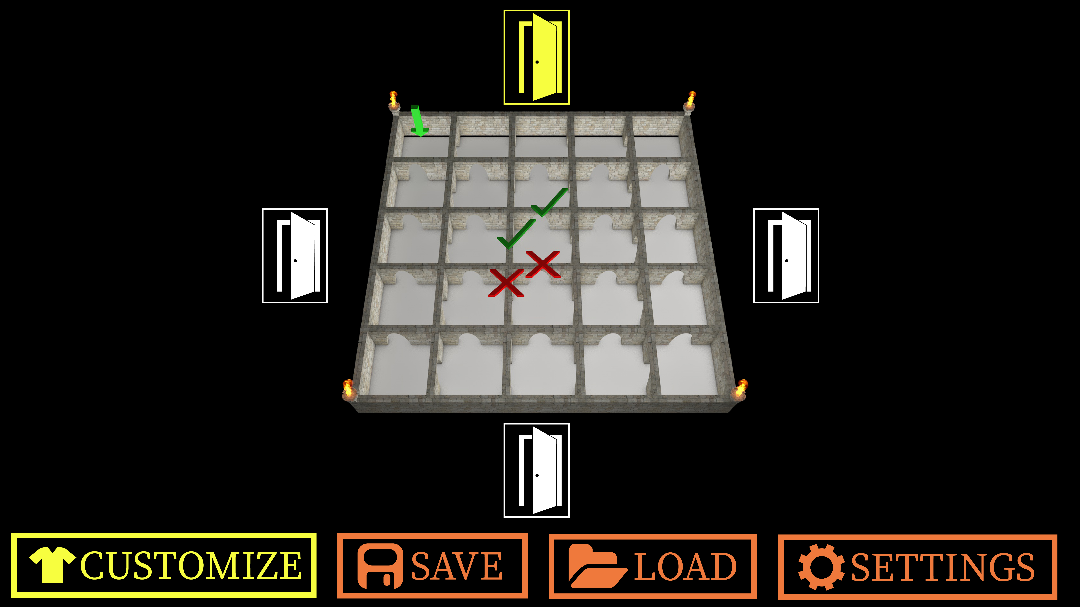
The UI is designed to be played using a clickable interface, but all functionality can be done via the keyboard. All the game’s interfaces will look similar to the selection screen depicted above, with the interface’s contents being displayed where the map and door buttons are currently displayed. The “Customize”, “Save”, “Load”, “Settings”, and “Help” (not depicted in the image) will always be shown at the bottom of the screen. The interfaces are all made in JavaFX 8 and use CSS styling wen needed.

Hardware Interfaces
Keyboard, mouse, and monitor will be needed to play the game. We only support 1080 x 1920 screen size for our game.

Software Interfaces
Our database that we will be making for questions and answers for the maze doors.

<Describe the connections between this product and other specific software components (name and version), including databases, operating systems, tools, libraries, and integrated commercial components. Identify the data items or messages coming into the system and going out and describe the purpose of each. Describe the services needed and the nature of communications. Refer to documents that describe detailed application programming interface protocols. Identify data that will be shared across software components. If the data sharing mechanism must be implemented in a specific way (for example, use of a global data area in a multitasking operating system), specify this as an implementation constraint.>

Communications Interfaces
Not applicable.

Other Nonfunctional Requirements

Performance Requirements
There are no performance requirements.

Safety Requirements
We do not have safety requirements for this software.

Security Requirements
We do not have security requirements for this software.

Software Quality Attributes
Meet the java development standards.

Other Requirements
Not at this moment.
Appendix A: Glossary
We do not have terms used that need describing in this document.

Appendix B: Analysis Models
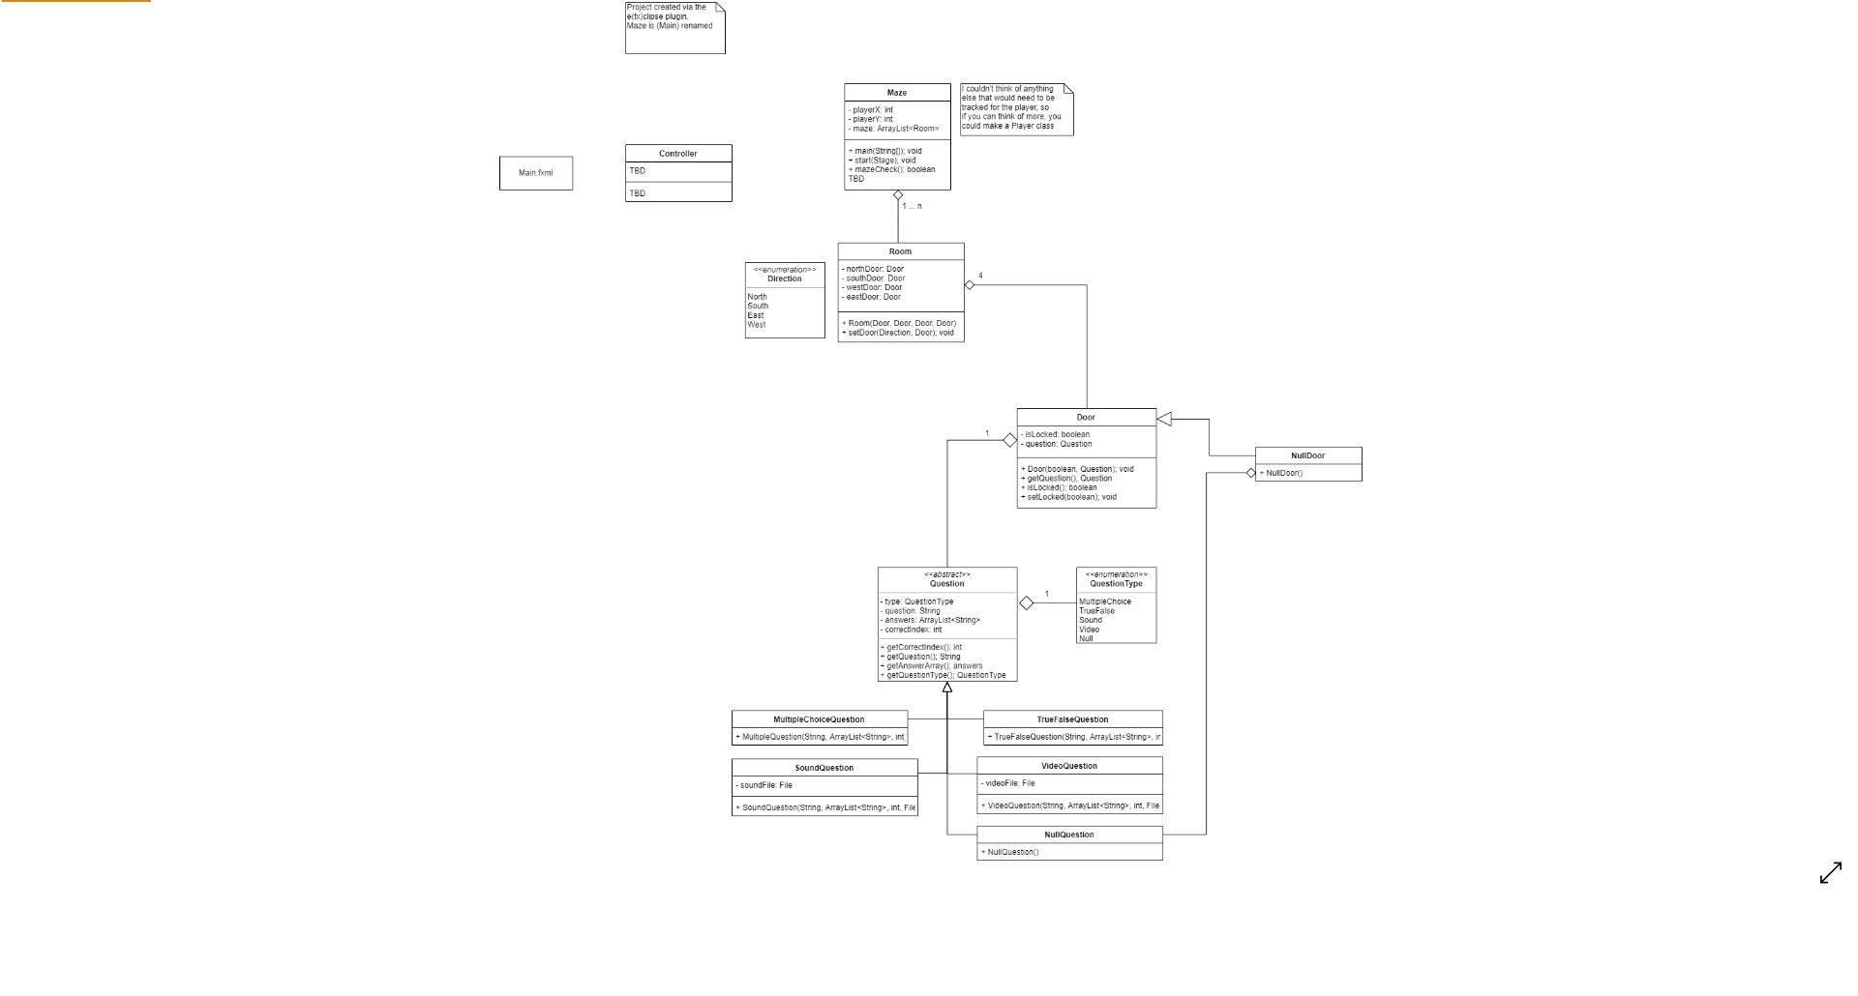
UML:

Appendix C: Issues List
Currently we are sitting pretty good 😊

